**Pitfalls**

**Recommended Test Order**

* K-means
* GMM

To check if an element is a member of a numpy array, use the keyword ‘in’:

Suppose A=[0,1,2,3], '1 in A' gives you True and '5 in A' gives you False.

**K-means**

Fit

Initialize random means (these will represent our clusters)

Update labels: (labels are just what cluster each point belongs to)

* Find Distances from each point to each mean, aka cluster (use euclidean distances, can import from scipy or from knn/collab filter)
* Update labels for each point based on what mean it is closest to (argmin is very useful here!)

Update means: (means are just from what point we are considering the location of each cluster)

* Find indices for the points for each label, aka cluster (can use np.where, logical indexing)
* Update the mean of each cluster based off the mean location of its points

Check if new means == old means to determine if we update again

Store means once done

*Tip*: Can use helper functions for 1. finding nearest clusters 2. updating means and 3. updating assignments

Predict

Find distances from features to stored means, [use argmin on distances to assign labels (if using KNN distances implementation of nxm array) along axis -1]

Can be done in one line if using helper functions

**GMM**

e-step

Use _posterior function to fill the prior probabilities for each gaussian. Each cluster represents a column in the matrix.

m-step

Update means, covariances, mixing weights for each cluster according to equations from slide 24 shown below (<https://nucs349.github.io/lectures/eecs349_gaussian_mixture_models.pdf>)

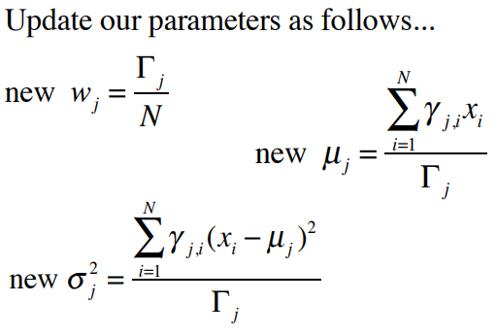

Here means = $μ_{j}$, mixing_weight = $w_{j}$, and the covariance matrix = ${σ_{j}}^{2}$.

You will also have to calculate $γ_{j,i}$ which is the corresponding column in assignment for each cluster. (use np.newaxis or reshape to convert 1-D to 2-D arrays)

These slides are also great if you want to understand what expectation maximization for GMM is actually doing!

log-likelihood

Calculate logpdf with the indicated function imported from scipy and add it to the log of mixing weights, this should be 1-2 lines

**FRQ**

If your implementations for the 2 clustering algorithms are too slow to run for the free response, you may import the sklearn implementations and use those instead.

<https://scikit-learn.org/stable/modules/generated/sklearn.cluster.KMeans.html>

<https://scikit-learn.org/stable/modules/generated/sklearn.mixture.GaussianMixture.html>

Once you’ve imported them, you can simply declare a new KMeans or GM object and use the fit() and predict() functions. Specifics on usage are detailed on the page.